New Policy created for the group of users on the network.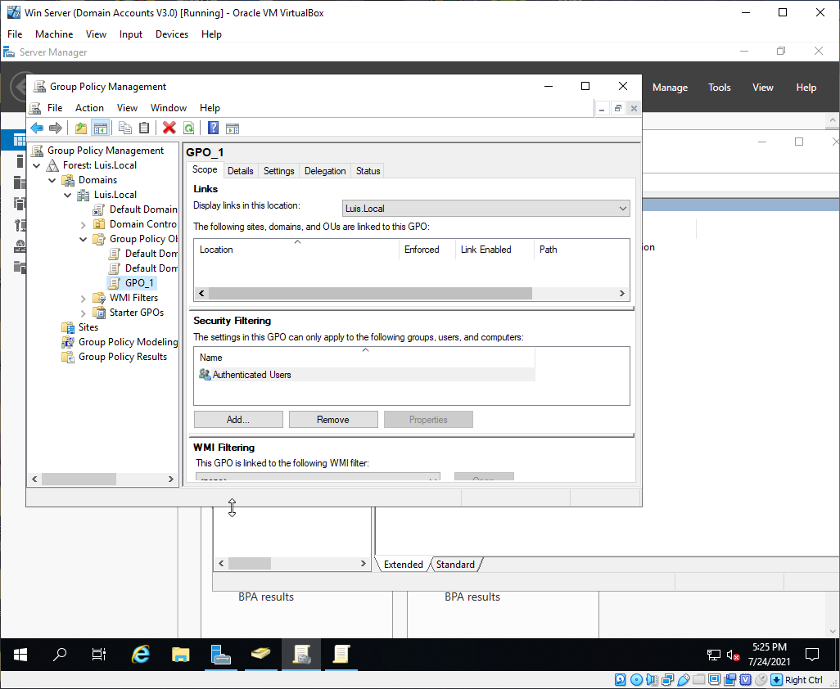

The policy setting for the entire policy.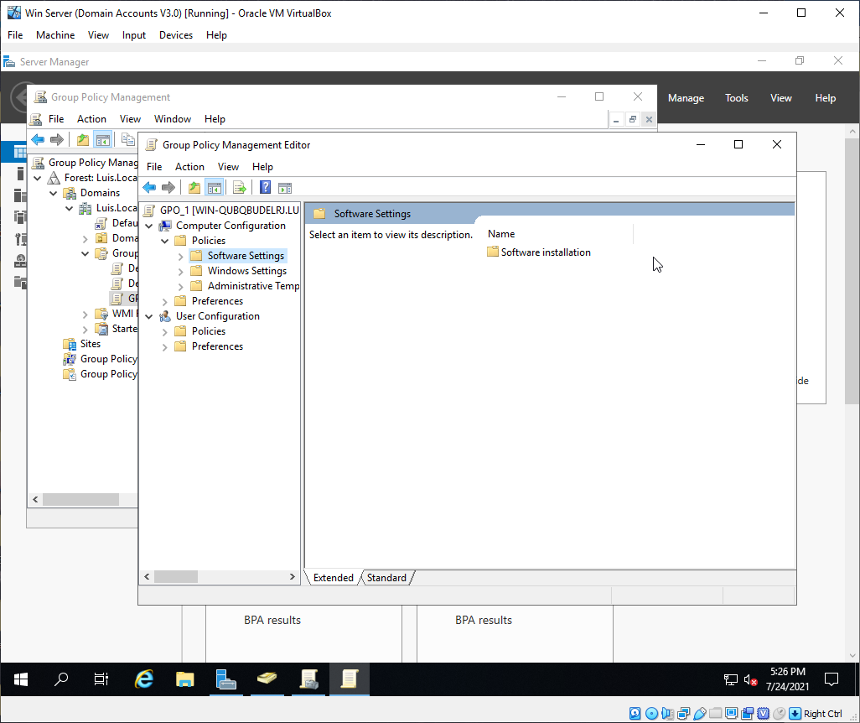

The Internet assignment list for what you would want to allow for the user to have access to.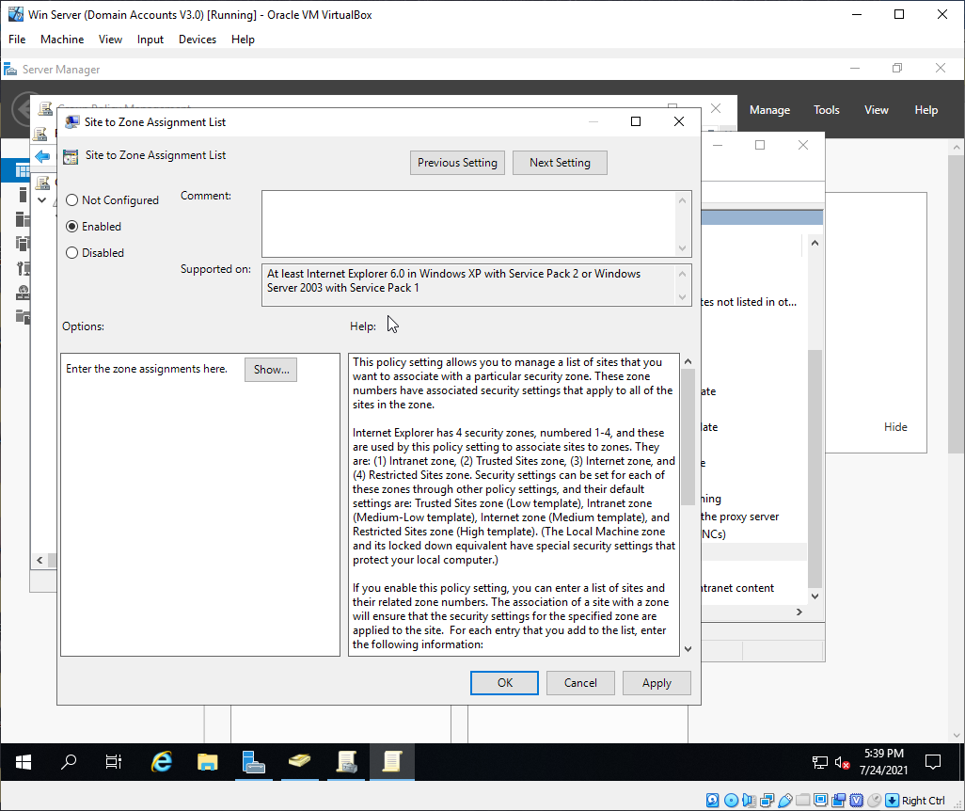

The deployment of Firefox when the users log into their computers, already pre-installed.